Machine Learning NOTES

**Feature Selection Techniques**

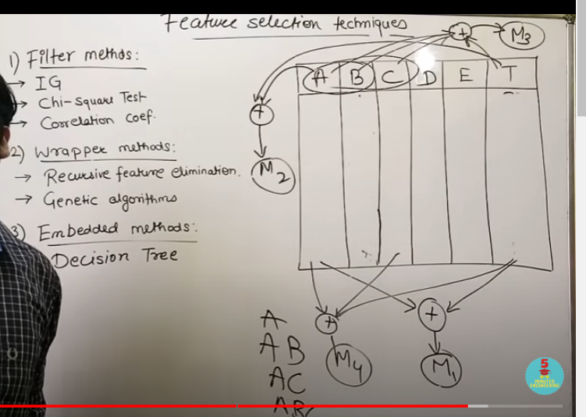

**MultiClass Classification Approaches ll One Vs All and One Vs One Classification**

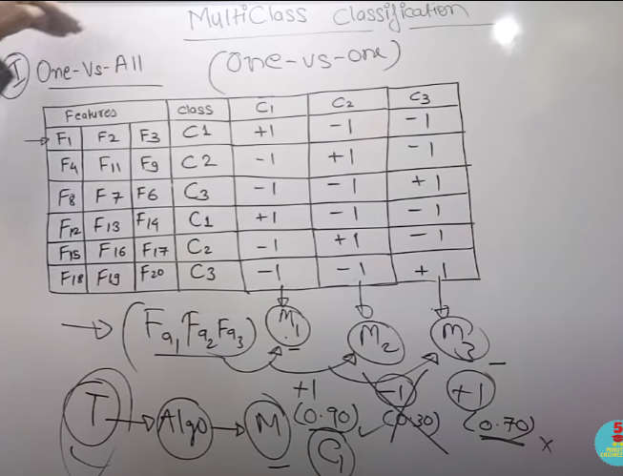

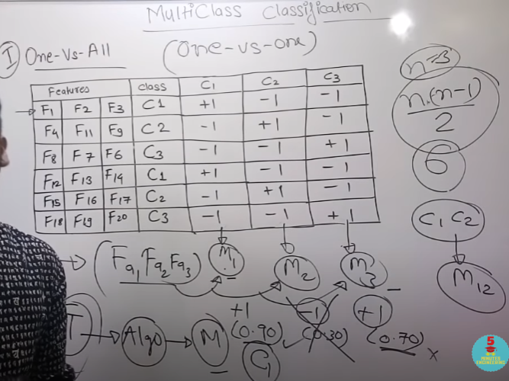

**Basics Of Principal Component Analysis**

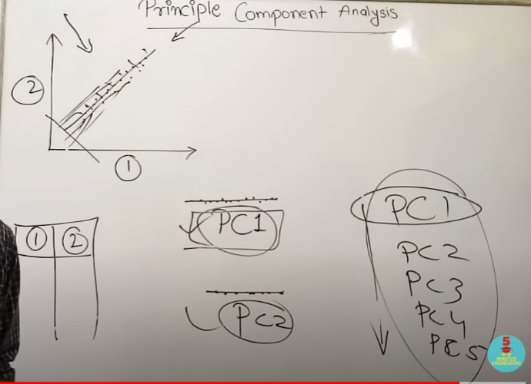

**Principal Component Analysis(PCA) Part-2 Explained with Solved Example in**

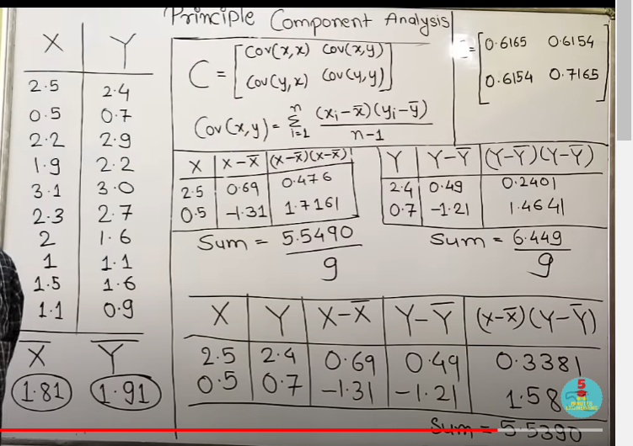

**Principal Component Analysis Part-3**

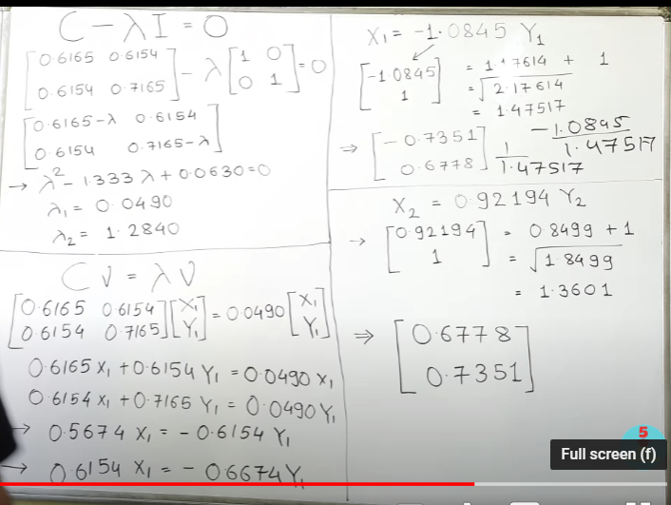

**Regression Analysis**

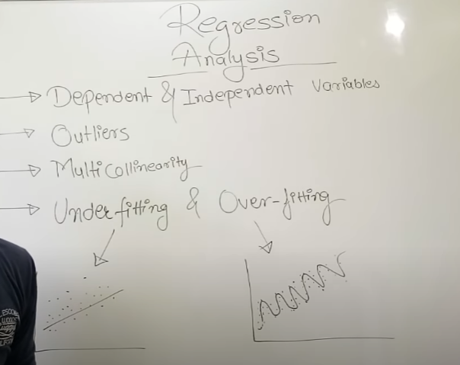

**Linear Regression And Logistic Regression**

**Confusion Matrix ll Accuracy,Error Rate,Precision,Recall**

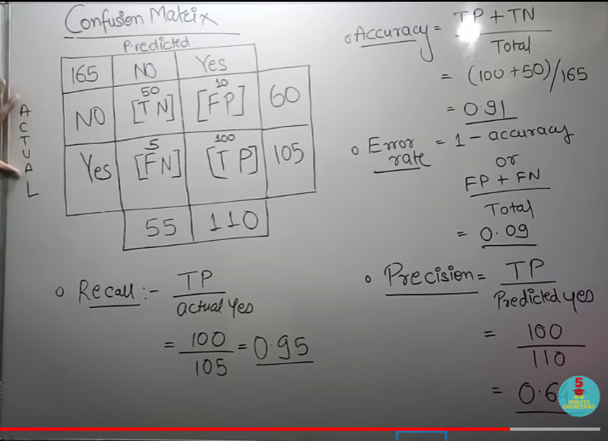

**Curse Of Dimensionality**

**Managing Missing Features**

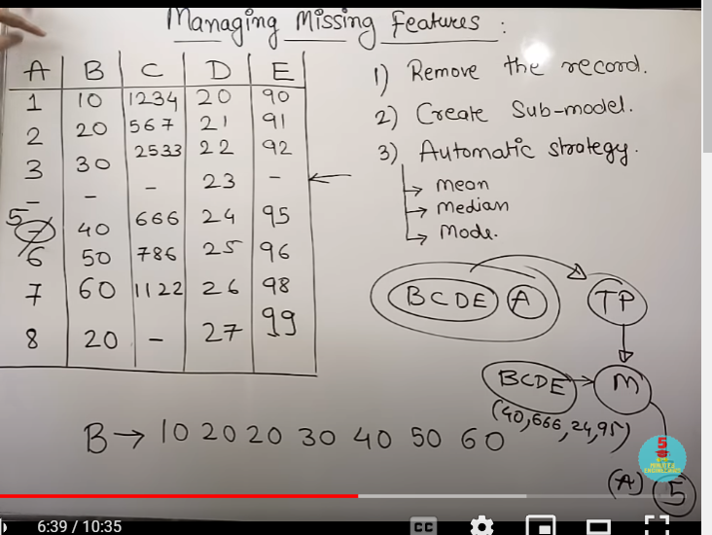

**Managing Categorial Data Explained with Examples**

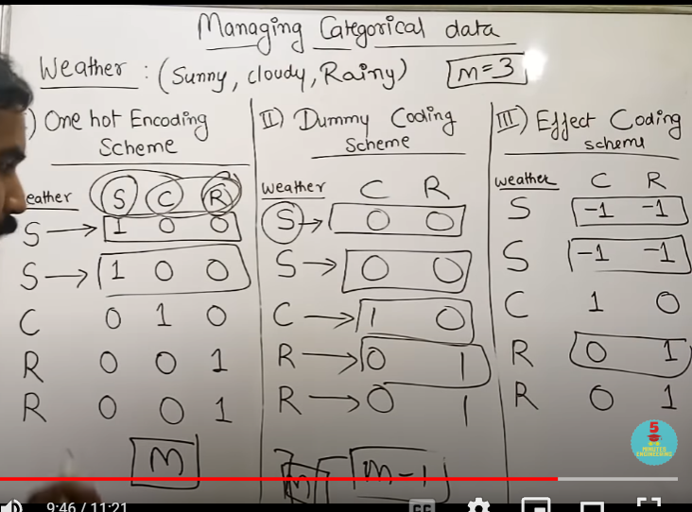

**Linear Regression**

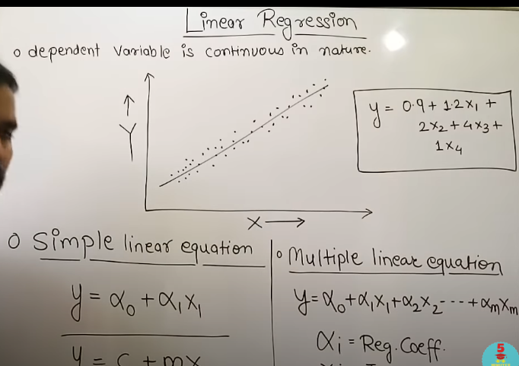

**Logistic Regression**

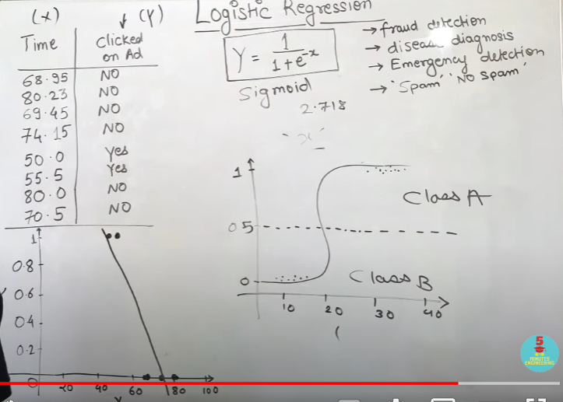

**Polynomial Regression**

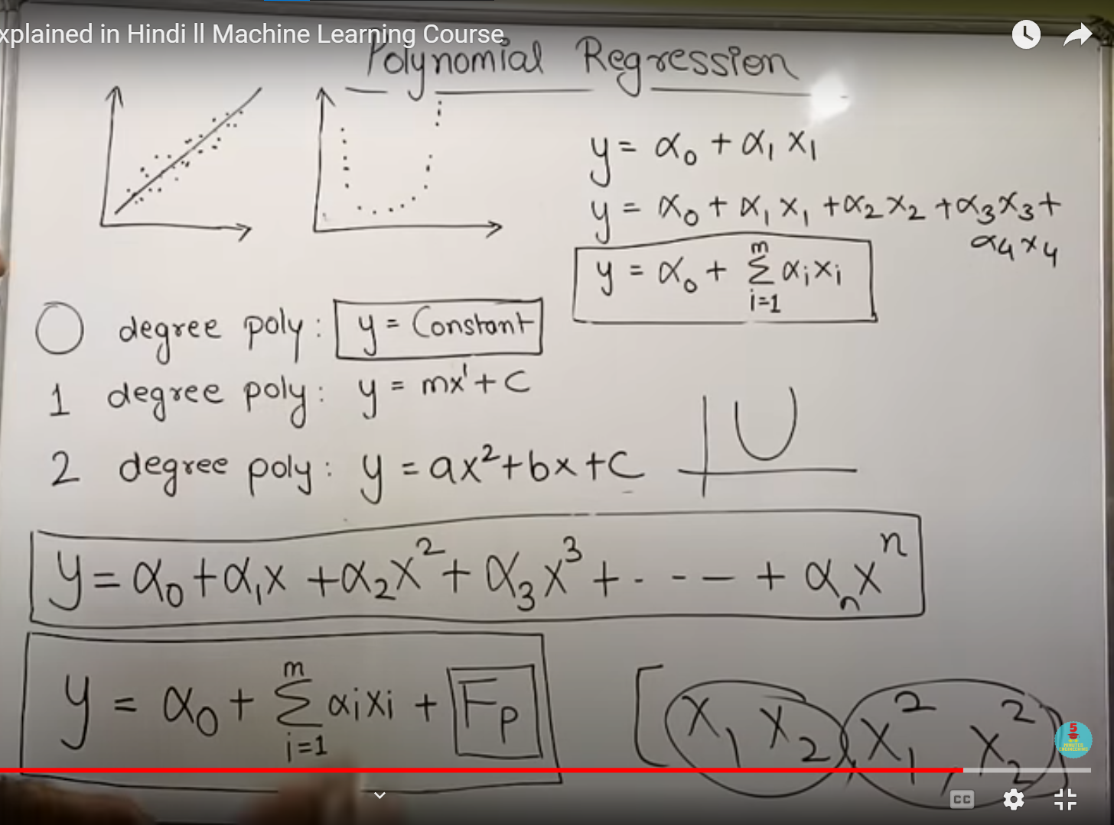

**Ridge Regression**

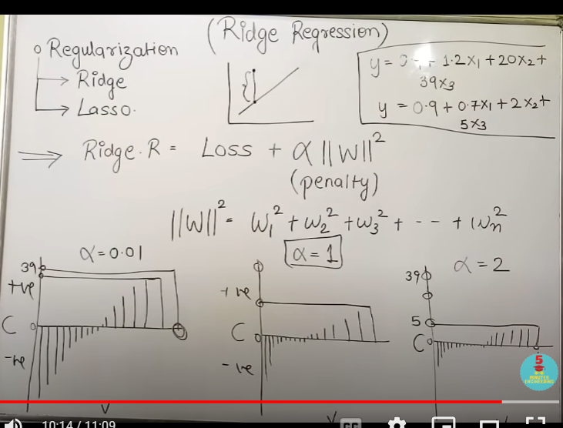

**Lasso Regression**

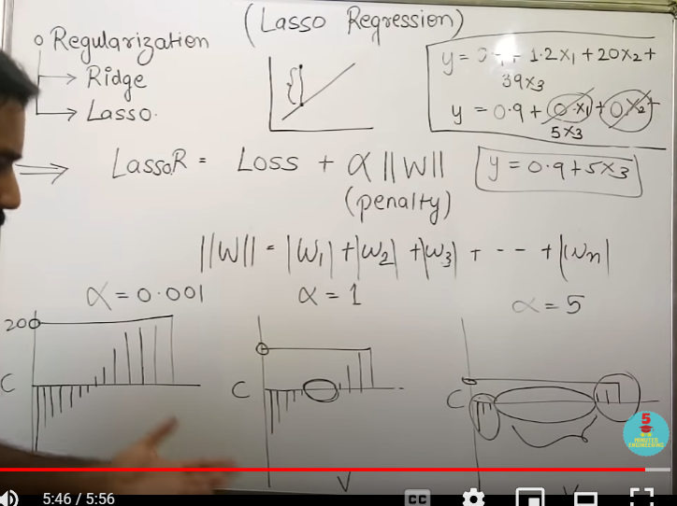

**Elastic Net Regression**

